Print 100

Cover (letter)

The Christmas Story
Family Christmas Eve Worship
December 24, 2009 at 5:00 p.m.

   Prelude
“Joy to the World” Ian Zych
“The First Noel” Zoe Hartz and Will Burleigh
“Infant Holy, Infant Lowly” Descant Choir

   Welcome and Opening Prayer Liz Wollaeger
* Hymn No 40
“Joy to the World”
   The Christmas Story
Scenes 1 and 2 An Angel Comes to Mary and Joseph
Hymn No. 27
“Gentle Mary Laid Her Child”
Scenes 3 and 4 Traveling to Bethlehem
Hymn No. 25
“Away in a Manger”
st. 1 and 2
Scene 5 The Wisemen
Hymn No. 66
“We Three Kings of Orient Are”
Congregation sings stanzas 1 and 5, and all refrains
Will Burleigh, Lillie Trammell, Chloe Birdsell, soloists
Christmas Joy Offering J. Rutter
“Star Carol”
Descant Choir
Macy Smith, Molly Webster, soloists
Prayer

   The Lighting of the Christ Candle
Hymn No. 60
“Silent Night”
Stanzas 1 and 2
   Benediction
   The Postlude
Improvisation on Christmas Carols

Cast
Narrator Mary McPheeters  Mary Molly Webster  Joseph Ian Zych  Innkeeper Laura Peterjohn  Gabriel Trent Swain  Shepherd 1 Ben Davis  Shepherd 2 Chloe Birdsell | Angel 1 Lindsey Miller  Angel 2 Hannah Smith  Wisewoman 1 Lillie Trammell  Wisewoman 2 Claire Jesberger  Wiseman 3 Blake Himes

The Christmas Joy Offering
Tonight’s offering, unless otherwise designated, will go to the PC(USA)’s Christmas Joy Offering, a fund to support the ministries of racial and ethnic education as well as the assistance program of the Board of Pensions.

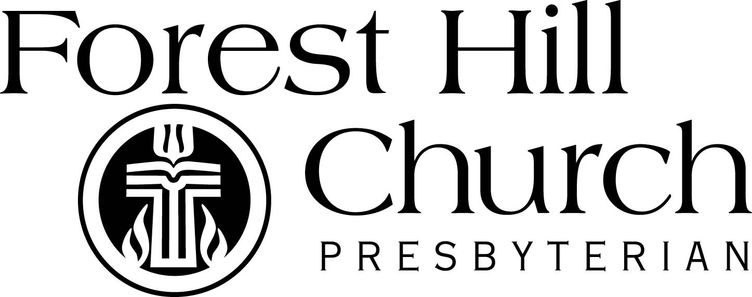

3031 Monticello Blvd., Cleveland Hts OH 44118
2116-321-2660 office@fhcpresb.org
www.fhcpresb.org

Luke 2: 1-20 (NRSV)
In those days a decree went out from Emperor Augustus that all the world should be registered. This was the first registration and was taken while Quirinius was governor of Syria. All went to their own towns to be registered. Joseph also went from the town of Nazareth in Galilee to Judea, to the city of David called Bethlehem, because he was descended from the house and family of David. He went to be registered with Mary, to whom he was engaged and who was expecting a child. While they were there, the time came for her to deliver her child. And she gave birth to her firstborn son and wrapped him in bands of cloth, and laid him in a manger, because there was no place for them in the inn.
In that region there were shepherds living in the fields, keeping watch over their flock by night. Then an angel of the Lord stood before them, and the glory of the Lord shone around them, and they were terrified. But the angel said to them, “Do not be afraid; for see—I am bringing you good news of great joy for all the people: to you is born this day in the city of David a Savior, who is the Messiah, the Lord. This will be a sign for you: you will find a child wrapped in bands of cloth and lying in a manger.” And suddenly there was with the angel a multitude of the heavenly host, praising God and saying, “Glory to God in the highest heaven, and on earth peace among those whom he favors!” When the angels had left them and gone into heaven, the shepherds said to one another, “Let us go now to Bethlehem and see this thing that has taken place, which the Lord has made known to us.” So they went with haste and found Mary and Joseph, and the child lying in the manger. When they saw this, they made known what had been told them about this child; and all who heard it were amazed at what the shepherds told them. But Mary treasured all these words and pondered them in her heart. The shepherds returned, glorifying and praising God for all they had heard and seen, as it had been told them.

